Motivation
Thermal Characterization of Multi-Finger MOSFET
Denise Leal
As technology advances new transistor devices are judged on two main qualities, size and speed. However, size and speed are directly correlated with how quickly a device overheats and breaks. New and innovative designs are great in theory, but before they are released they must be tested and thermally characterized. As new devices are designed and created we must choose the best method to characterize them with. We know transistors have hot spots because of their non uniform electrical potential areas, and in testing new transistors we need to be able to locate these hot spots to better design the circuitry around them. Some methods are invasive and as a result measurements can be inaccurate and devices can be damaged. Thermoreflectance is the preferred method for obtaining quantitative data because it is non invasive and still extremely accurate. Thermoreflectance will not destroy the device since no physical object ever comes in contact with the device. This method is more accurate than others because the thermal leakage at a contact point is eliminated, since there is no contact point. High spatial resolution is another benefit of thermoreflectance, since this method delivers a picture it allows you to visually see where the “hot spots” are located and if there are multiple “hot spots”.
Set Up
The device tested was a multi-finger MOSFET that had two gate fingers and is pictured in Figure 1. Each gate had a width of 20µm and a length of 180nm. The source of our device was grounded and our gate voltage was a constant DC source that

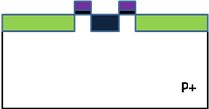
Source

Gate
Drain
Figure 1

ranged between 0V and 2V and was incremented by 0.5V. Our drain to source voltage was a square wave that ranged between 0V and 3V and was incremented by 0.2V. We used a square wave for our Vds with the frequency based on the cameras frequency. We wanted our camera to take a picture both at the on position and the off position of the Vds square wave, so that our camera algorithm could subtract the two and we could obtain our single AC image. In order to achieve that we needed our Vds frequency to be half of our camera frequency.
The thermoreflectence set up consists of the CCD camera, the microscope, the objective lens, the oscilloscope, the function generator and the source meter shown in Figure 2. As a light source we used white light because it provided good thermal images. The white light would enter the microscope and hit the beam splitter located inside. The beam splitter would then reflect the light downward through the objective lens and onto the device. The device would then reflect the light back up through the objective lens and hit the beam splitter once more. However, this time the light passes straight through and is not reflected by the beam splitter. The reflected light would be
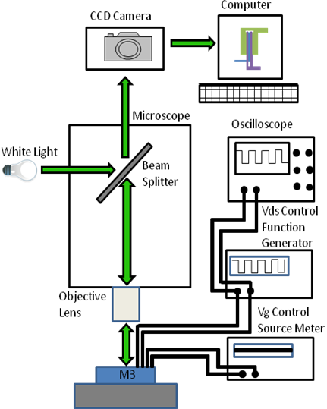
Figure 2: Thermoreflectance Set Up

caught by the CCD camera and the camera would then send the images and data to the computer for analysis.
A main component of the thermoreflectance set up is the thermoreflectance coefficient, Cth. This coefficient is based on every materials reflection coefficient, R, weak dependence on temperature. In order to calibrate Cth you would place the device on a Thermo-Electric Cooler (TEC) stage and modulate the temperature. Then you would observe how the intensity of the reflection coefficient changes with the change in temperature and from that information calibrate Cth. However, due to the time constraints we were unable to calibrate Cth for our device and our results are uncalibrated.

Results
We were able to acquire both quantitative results and un-calibrated qualitative results. Our best results were when Vg=2V which is why we performed most of our numerical analysis for Vg=2V. In Figure 3 you can see the IV curves which were obtained while taking the thermal images of the device. On the curves we can see when the device is in triode region and when it is in saturation region. Our range of values for Vg and Vds were obtained by testing the transistor and trying to obtain the IV curves and observing when the transistor stopped behaving like a transistor. From the IV curves we obtained the power curves for our device, seen in Figure 4. The power curves follow a quadratic trend near the beginning and a linear trend near the end of the curves.
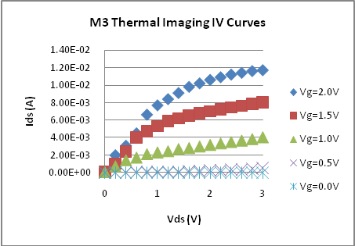
Figure 3: Graph of Ids as a function of Vds.

We assumed our transistor had a constant thermal resistance, from the top of our device to the bottom of our substrate. In order to test our assumption we superimposed a maximum temperature versus the drain to source voltage graph with the power versus the drain to source voltage
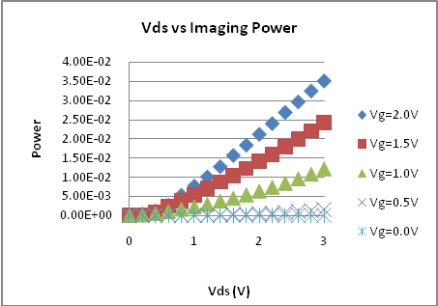
Figure 4: Graph of Power as a function of Vds.
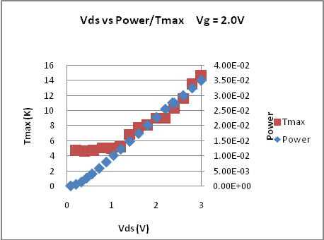
Figure 5: Graph of Vds vs Power/Tmax

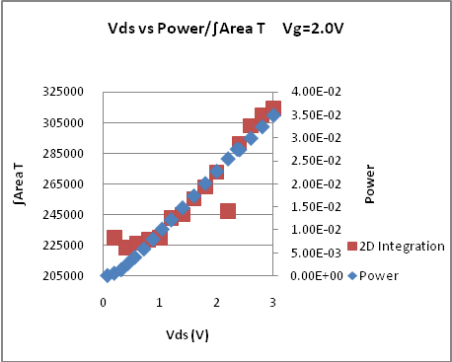
Figure 6: Graph of Vds vs Power/∫_{Area} T

graph, seen in Figure 5. The x-axis was the same for both, although each graph has its own y-axis. We can see that towards the end of the graph both curves follow really similar trends, whereas near the beginning the maximum temperature seems constant. The constant region in the maximum temperature curve is representative of the noise level, since our device is not clearly visible in a thermal image until Vds is 1.2V. Our next step in testing our assumption is taking an area integration of our device. We do this because our device is three dimensional, so our hot spot area can also change in size with a change in depth of our device. We use the Half Height Full Width approach to find a threshold temperature for which to perform the integration. As seen in Figure 6, we superimposed the power curve with ∫_{Area} T curve both over Vds again. The ∫_{Area} T curve more closely resembles the power curve in comparison to how closely the Tmax curve resembled the power curve. We can see a quadratic region near the beginning and the linear region near the end. This shows that our device does indeed have a constant thermal resistance.
Further analysis was performed on the cross section of the device. Again, for Vg=2.0V, we took a cross section of values for all Vds for which the device had a clear thermal image. As seen in Figure 7, intuitively and visually, as Vds becomes larger so does the overall temperature. On the figure we can see the two source fingers, which are the two outside mounds, the drain finger which is the center peak and the two gate fingers, which are the two valleys. We can also see that the drain peak is always a few degrees higher than the source peaks. This is because

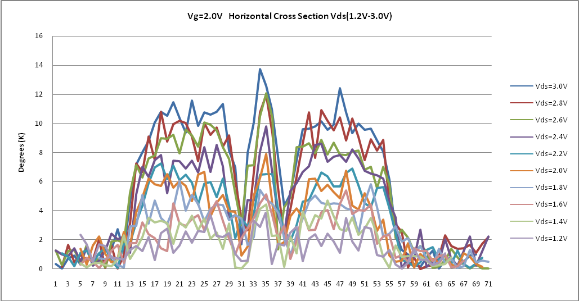
Figure 7: Cross section of device for Vg = 2.0V and Vds = 1.2V to Vds = 3.0V

our device is a transistor, which means it is a three terminal device that has an electrical potential near the drain. When the electrons enter this region they obtain more energy which they release along the lattices through collisions. The energy released by the electrons can be seen in the higher temperature.
When we took the thermal images of the device we took raw images, as we increased Vg and Vds we took an image for each. However, these raw images do not account for the ambient noise. In order to obtain baseline images for every Vg we subtracted the Vds=0V from the corresponding Vg. Once we performed the corresponding subtractions we compared all five Vg for Vds = 3V. As can be seen in Figure 8(a-e) the thermal clarity increases as Vg increases. This is because as Vg increases the overall device temperature increases which means

there is a greater reflectivity difference between the device and the surrounding ambient. We can see that for lower Vg values the device is not completely defined, this is because the device is not on, Vg is not high enough to create a channel between the drain and sources and therefore very little, if any current is passing at all. Once the device is fully on then we can see both source fingers clearly defined, as well as the drain and gate fingers. Another observation is that, although larger Vg values do not seem to have a great difference we can see that the drain contact point has a hot spot along the horizontal for Vg=2.0V and not for Vg=1.5V. Although the differences are subtle they are still there.
We were able to make some overall un-calibrated quantitative measurements. We observed that with every 0.5V increase in Vg the maximum temperature increased by approximately 4 degrees Kelvin. The maximum temperature reached was almost 14(K), however we must keep in mind this is uncalibrated.
Future Work
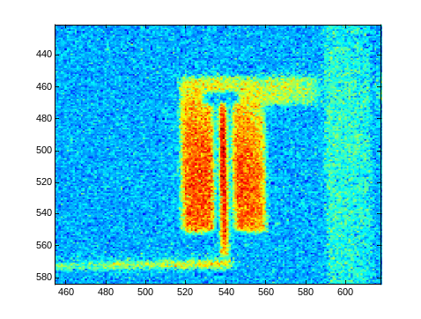
One of the immediate next steps would be to calibrate the thermoreflectance coefficient, Cth, so that our quantitative data is not only relative to each other, but actually accurate. Once we calculate Cth we would also be able to perform quantitative comparisons between our device and other multi-fingered MOSFETS. This would give us a greater intuition about which multi-finger MOSFET designs are more efficient. We would also need to perform vertical analysis on both source fingers, like the analysis performed on the device’s cross section. This would show us numerical values about how evenly, or unevenly, the two source fingers heat up. In order to further characterize our device we would also need to take measurements at cryogenic temperatures, which we could not perform due to time constraints.

Figure 8d: Vg= 1.5V Vds = 3.0V
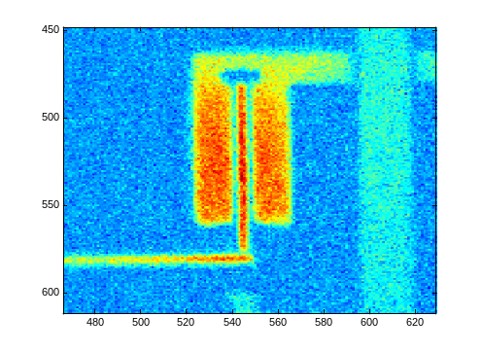

Figure 8e: Vg = 2.0V Vds = 3.0V
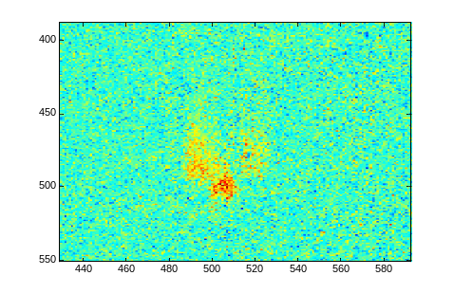

Figure 8a: Vg = 0.0V Vds = 3.0V
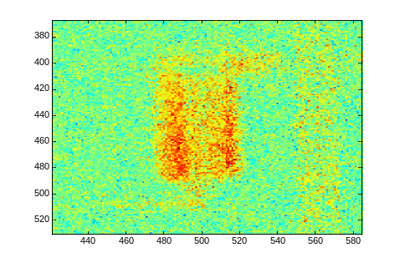

Figure 8b: Vg=0.5V Vds = 3.0V
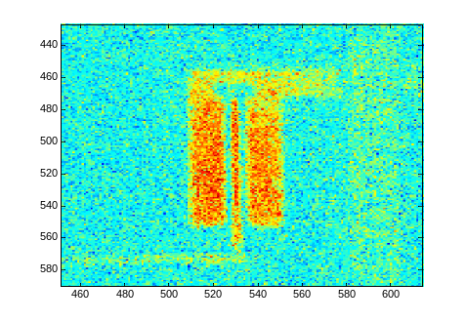

Figure 8c: Vg=1.0V Vds = 3.0V

